# Name: Ngo Quang Khai StudentID: s3836387

## 

## Activity 1: Javascript runs Client side

Javascript is executed **client side**. What does this mean? How does it help the server?

### Server Side Validation

## 

### Client Side Validation

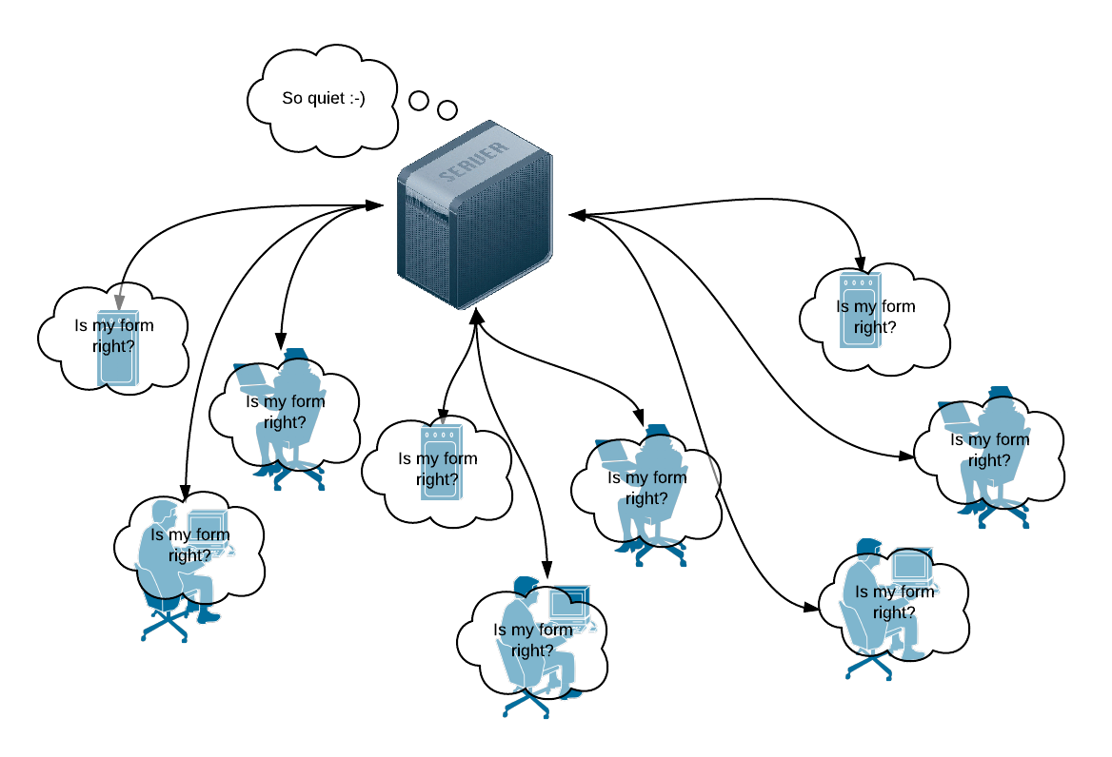

Ans: The JS will help reduce the amount of faulty form got send to the server by validating the form on the client side first. It will reduce the server processing time and clear the bandwidth for another user. If JS validation return false on the client side, the form will not be send to the server.

Activity 2: Javascript Implementation

Javascript can be included into a html document in three ways: **External**, **Embedded** and **Inline;** and also into event handler attributes:

|  |
| --- |
| 1. <html> 2. <head> 3. <!-- External JS --> 4. <script type="text/javascript" src="tools.js"></script> 5. <!-- Embedded JS--> 6. <script type="text/javascript"> 7. function displayDate() { 8. document.getElementById("date").value = new Date(); 9. } 10. </script> 11. </head> 12. <body> 13. <h1>What's the Date?</h1> 14. <p><input type="text" id="date" name="date" value="Click the button" /> 15. <!-- Event handler JS --> 16. <button onclick="displayDate()">Display Date</button></p> 17. <p>&copy; Copyright Date Awareness Inc 1990 - 18. <script type="text/javascript"> 19. /* Inline JS */ 20. var d = new Date(); 21. document.write(d.getFullYear()); 22. </script> 23. <noscript>2001</noscript> 24. </p> 25. <h6>Ask us about the benefits of dynamic dating</h6> 26. </body> 27. </html> |

**Line 3:** External script. What sort of javascript code would you expect to find in tools.js?

Ans: Functions that are commonly used for many pages

**Lines 4 - 8 & 13:** Embedded script and event handler script: How is the function displayDate() called?

Ans: It was called by event handler JS on line 16

**Lines 19 - 22:** When does this code run? What does it show?

Ans: The code run when the <p> element is loaded. It show the current year

**Line 23:** Why do we need <noscript> tags? What will it show and when?

Ans: For cases when the browser does not support JS code. It will show the provided text instead

## Activity 3: Responding to Events, running Functions

By now you should understand that every element can be given a unique id. The built in javascript function document.getElementById() can be used to:

* Return a reference to any element that has a unique id.
* Read, process and change values (even styles) dynamically.

The **button** generates a click event and calls a **function** in the previous example. In the lab we will also look at the onsubmit**,** onchange and onkeyupevents in the lab, but there are plenty of other events to look at.

Analyse this function. What does it do and how? When (and how) might you call it? Examine closely what the focus() and select() functions do in this code.

|  |
| --- |
| 1. // This function calculates a price for a cinema booking 2. function calculatePrice() 3. { 4. var numSeats = parseInt(document.getElementById('seats').value); 5. if (isNaN(numSeats)) 6. { 7. alert('You are a bad customer! Type numbers next time.'); 8. document.getElementById('seats').focus(); 9. document.getElementById('seats').select(); 10. return false; 11. } 12. var seatPrice = 20; 13. var salePrice = seatPrice * numSeats; 14. document.getElementById('price').innerHTML = salePrice.toFixed(2); 15. return true; 16. } |

Ans: the function calculatePrice() is used to calculate the price base on how many seats the user is booking.

If the user did not input an integer the if function will be true -> alert the user -> focus on the element that has ‘seats’ id and select element with the ‘seats’ id -> return false.

If the user input integer, the function will calculate the total price -> get the element with id ‘price’ set with the calculated price with 2 decimal places.

Why is using an alert box in a form validation script bad practice? What nicer methods can we use to alert users to errors? Think about your experience as a web user, what other ways have you been notified of errors on a web form?

Ans: Because you will have to through each alert box if you have multiple errors and user might be lost.

Another way to alert user is changing the input element to red and generate a span box that said the error under the input element.